**Adavantages of java**

**Java Features:**

1. Platform Independence and Portable
2. Object-Oriented
3. Robust and Secure
4. Multithreading and Interactive
5. High Performance
6. Compiled and Interpreted
7. Dynamic and Extensible
8. Familiar, Simple, and Small
9. distributed

**Explanation of 4 Features:**

1. **Platform Independence and Portable**:
   * Java follows **Write Once, Run Anywhere (WORA)**, allowing code to run on any system with a JVM.
   * Java bytecode is platform-independent and can run on various operating systems like Windows, macOS, and Linux.
2. **Object-Oriented**:
   * Java uses **classes and objects** to model real-world entities, promoting reusability and maintainability.
   * Key OOP principles: **Inheritance** (code reuse), **Polymorphism** (method flexibility), **Encapsulation** (data hiding).
3. **Robust and Secure**:
   * Java is designed for **error-free** operation with features like **garbage collection** and **exception handling**.
   * Java’s **security features** (Security Manager, bytecode verification) protect against unsafe operations.
4. **Multithreading and Interactive**:
   * Java supports **multithreading**, enabling concurrent task execution for more efficient applications.
   * Java provides **Swing** and **JavaFX** for building interactive, user-friendly **graphical user interfaces (GUIs)**.

**High Performance**:

* Java achieves high performance through **Just-In-Time (JIT) compilation**, which compiles bytecode to native code for faster execution.

2.

Give the general structure of java program and explain reefer book

**Package**: Organizes your code into folders (like com.example).

**2. Import: Allows you to use pre-built classes from other packages.**

* Example: import java.util.Scanner;

**3. Interface: Defines methods that a class must implement.**

* Example:

interface Greetable { void greet(); }

**4. Class: Defines the blueprint for creating objects and contains methods.**

* Example:

class Car { String color; }

**5. Main Method: The entry point where the program starts running.**

* Example:

public static void main(String[] args) { System.out.println("Hello!"); }

**6. Curly Braces { }: Used to group code into blocks.**

* Example:

if (true) { System.out.println("True"); }

**7. Method: A function that performs an action or returns a value.**

* Example:

public int add(int a, int b) { return a + b; }

3 jdk

### ****JDK (Java Development Kit)**** - Simple Explanation:

1. JDK provides all the tools you need to write, compile, and run Java programs, including a compiler (javac), runtime environment (JRE), and libraries.
2. It includes the Java Runtime Environment (JRE), which allows Java programs to run on your computer.
3. JDK is necessary for Java developers because it has everything to create and test Java applications.

#### javac – Java Compiler

* **Purpose**: This command is used to compile Java source code (.java file) into bytecode (.class file).
* **Syntax**:

javac filename.java

* **Example**: If you have a HelloWorld.java file, you can compile it using:

javac HelloWorld.java

#### . java – Java Interpreter/Launcher

* **Purpose**: This command is used to run Java programs. It executes the bytecode file (.class file) created by the javac compiler.
* **Syntax**:

java ClassName

* **Example**: After compiling HelloWorld.java into HelloWorld.class, you run it like this:

java HelloWorld

#### jdb – Java Debugger

* **Purpose**: This command is used for debugging Java programs.
* **Syntax**:

jdb ClassName

* **Example**: To debug a program, you would use:

jdb HelloWorld

#### java -jar – Run JAR Files

* **Purpose**: This command is used to run a Java application from a .jar file.
* **Syntax**:

java -jar fileName.jar

* **Example**: After creating a HelloWorld.jar file, you can run it with:

java -jar HelloWorld.jar

#### . javap – Disassembler for Java Bytecode

* **Purpose**: This command disassembles Java bytecode into readable code to inspect the structure of a class file.
* **Syntax**:

javap ClassName

* **Example**: To inspect a compiled HelloWorld.class file, you would use:

javap HelloWorld

#### javadoc – Java Documentation Generator

* **Purpose**: This command generates HTML documentation from Java source code comments.
* **Syntax**:

javadoc ClassName.java

* **Example**: If your class has properly formatted comments, you can run:

javadoc HelloWorld.java

This will create HTML files containing API documentation for your classes.

**javah (Before Java 8)**

**Purpose**:

* javah was used to generate C header files from Java classes that have native methods. Native methods are written in languages like C or C++.

**Syntax**:

javah ClassName

**Example**: If you have a class MyNativeClass.java with a native method, you would run:

javah MyNativeClass

This creates a MyNativeClass.h file for use in your C code.

**2. appletviewer**

**Purpose**:

* appletviewer was used to run and debug Java applets (small applications) outside of a web browser.

**Syntax**:

appletviewer AppletFile.html

**Example**: If you have an applet in the file HelloApplet.html, you can run it with:

appletviewer HelloApplet.html

This will open the applet in a window to be tested and debugged.

### 1…Datatypes refer chart

* **Primitive data types** are the basic, predefined types in Java that represent simple values like numbers, characters, and boolean values.  
  **Example**: int age = 30;

**Non-Primitive (Reference) Data Types:**

* **Non-primitive data types** are more complex types in Java that store references to objects, like **String**, **Arrays**, and **Classes**.  
  **Example**: String name = "Alice";

**Primitive Data Types**

1. **byte**: A small integer (-128 to 127).
   * Example: byte b = 10;
2. **short**: A medium-sized integer (-32,768 to 32,767).
   * Example: short s = 1000;
3. **int**: A standard integer (-2^31 to 2^31-1).
   * Example: int i = 50000;
4. **long**: A large integer (more than int range).
   * Example: long l = 100000L;
5. **float**: A decimal number with single precision.
   * Example: float f = 10.5f;
6. **double**: A decimal number with double precision.
   * Example: double d = 20.99;
7. **char**: A single character (e.g., 'A').
   * Example: char c = 'A';
8. **boolean**: Represents true or false.
   * Example: boolean isJavaFun = true;

**Non-Primitive Data Types**

1. **String**: A sequence of characters (text).
   * Example: String greeting = "Hello, World!";
2. **Array**: A collection of elements of the same type.
   * Example: int[] numbers = {1, 2, 3, 4, 5};
3. **Interface**: A contract that classes must follow (defines methods).

interface Animal {

void sound();

}

class Dog implements Animal {

public void sound() {

System.out.println("Woof!");

}

}

Platform

• **Java Program**: Developer writes source code in a .java file.

• **javac (Compiler)**: The Java compiler converts the .java file into bytecode

• **Bytecode**: The compiled bytecode is platform-independent.

• **JVM (Java Virtual Machine)**: The JVM executes the bytecode on any platform.

• **Platform Independence**: Bytecode can run on any system with a compatible JVM.

• **Different OS Compatibility**: Java runs on Windows, Linux, Mac, and other OSes.

• **JVM-Specific**: The JVM is tailored to the specific OS but can run the same bytecode.

• **Write Once, Run Anywhere**: Java code is written once and runs on multiple platforms.

• **No Code Modification**: Bytecode doesn’t need to be modified for different operating systems.

• **Universal Execution**: Java applications can be executed safely on any device with a JVM.

CONSTRUCTOR , 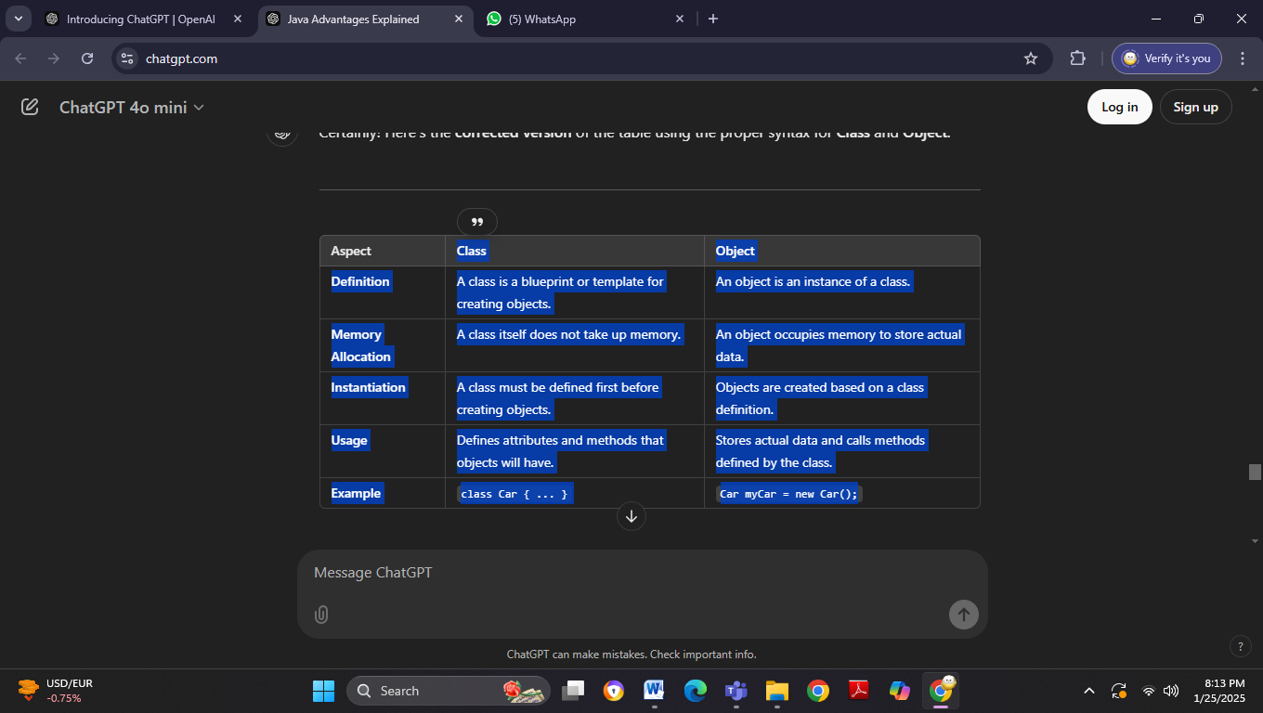DIAGRAM OF PLATFORM ,PACKAGE ,DIFEERENCE , CHART